DIRECTIONS TO THE FIELD
**WATCH FOR SIGNS**
From Duke Point Ferry/Nanaimo:
Take Hwy 1 South to Nanaimo Airport, turn left onto Spitfire Rd. ***
From Victoria:
Take Hwy 1 North to Nanaimo Airport, turn right onto Spitfire Rd. ***
*** enter the round-a-bout and exit at the 3rd road.

COURSE PLANS
Not to scale. Course may be altered due to weather, field conditions and/or safety.

Saturday, 760 yds
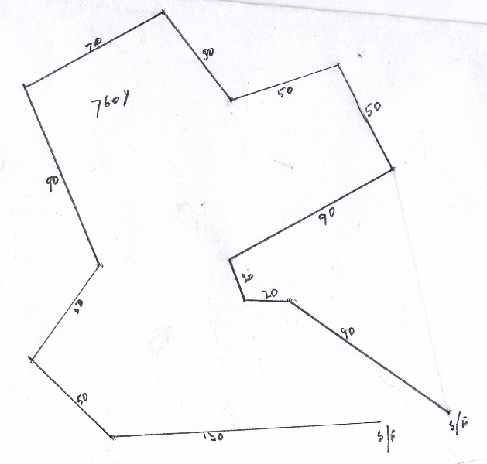

Sunday, 765 yds
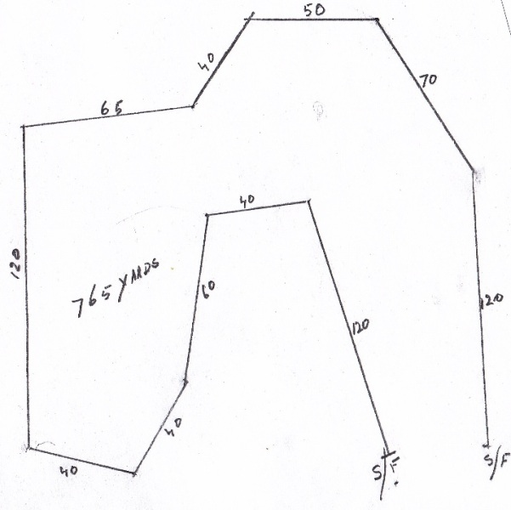

ENTRY FEES
PER HOUND, PER TRIAL $17.00
ADDITIONAL HOUND SAME OWNERS $15.00
SINGLES STAKES (limited to 10 hounds) $17.00
ADDITIONAL HOUND SAME OWNERS $15.00
LATE/DAY OF TRIAL ENTRIES, per hound $20.00
PUPPY, OLD TIMER, KENNEL OR BREEDER $5.00
VETERANS STAKE (entered in Open or Mixed stake) nil
LISTING FEE* $8.61
- A listing fee as established by CKC must accompany the entry of the dog for which a CKC registration number or ERN is not shown on the entry form.

Official Premium List
These events are held under the rules of the Canadian Kennel Club
See Page 5 of the Premium List for the current (April, 2011) information on the Non-Member Participation fee.

Pre-entries close at noon Wednesday June 1, 2011
Day of trial entries close 1/2 hour before Roll Call

ROLL CALL
Saturday 9:30 a.m. Sunday 9:00 a.m.
Puppies & Old Timers: 1:00 p.m.

LURE COURSING EQUIPMENT
Will be gas or battery powered DRAG lure machine with white plastic bags.
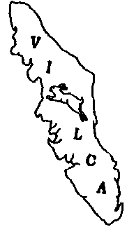
.

Vancouver
Island
Lure
Coursing
Association

TWO C.K.C. LURE COURSING TRIALS
June 4 & 5, 2011
TO BE HELD at NANAIMO AIRPORT
3359 Spitfire Rd
CASSIDY, BC V0R 1H0
Camping is not permitted on the field.

Field Trial Secretary to whom all entries must be sent
Sheila Barclay
109 - 3142 Cedar Hill Rd., Victoria, B.C. V8T 3J6
Phone: (250) 595-7588 e-mail: Basenjis@shaw.ca
MAKE CHEQUES PAYABLE TO:
“VANCOUVER ISLAND LURE COURSING ASSOCIATION”
(Sorry, no Fax or Credit Card entries available)
V.I.L.C.A. would like to thank the following Sponsor:
Orru Basenjis for LQS & Veteran both days
There will be a concession available at this trial.

VANCOUVER ISLAND LURE COURSING ASSOCIATION

President - Debra Verzyl Vice President – Carolyn Hutchison
Secretary – Heather Girgan Treasurer – Judy Dixon

FIELD TRIAL COMMITTEE
Trial Secretary: Sheila Barclay Trial Chairperson: Blair Shinski
Field Clerks: Heather Girgan, Laurel Deptuch, Linda Quilty
Lure Operator: Howie Wirsch & John Girgan
Hunt master: Laurel Deptuch, Judy Dixon, Leigh Smith

CANADIAN KENNEL CLUB
B.C. Director, SW Zone: Margaret Jones Coursing Rep: Debra Verzyl
A/CEO, Mrs. Leila Bahorie: 200 Ronson Dr., #400, Etobicoke ON M9W 5Z9

ELIGIBLE ENTRIES
Open to the following Hound Group 2; Afghan Hound, Basenji, Borzoi, Deerhound (Scottish), Greyhound, Ibizan Hound, Irish Wolfhound, Pharaoh Hound, Saluki or Whippet and Toy Group 5; Italian Greyhound that is one year old or older on the day of the trial. All entrants must be registered, or eligible for registration, with the Canadian Kennel Club or have an Event Registration # (ERN), or Performance Event # (PEN). Hounds presently disqualified under any jurisdiction cannot compete. Hounds with breed disqualifications, altered or neutered are eligible to enter the lure coursing trial. Hounds must be pre-qualified before entering their first trial in Canada. The original signed certificate must be submitted to the Field Trial Secretary with the entry form

AWARDS
Rosettes for 1st through NBQ: Open Stake

Prizes and Rosettes for:
Best of Breed Best in Old Timers Fun Run LQS
Best in Singles Stake Best in Kennel Stake Best Puppy
Best Veteran Best in Breeder Stake

CHAMPIONSHIP POINTS will be awarded as follows:
1st place - 4 X number competing to a maximum of 40 points;
2nd place - 3 X number competing to a total of 30 points;
3rd place - 2 X the number competing to a total of 20 points;
4th place - 1 X the number competing to a total of 10 points:
NBQ; no points

OUR JUDGES
Judy Dixon, 10143 Klitsa Dr, Port Alberni BC V9Y 9A7
John Girgan, 50 – 3560 Hallberg Rd, Ladysmith BC V9G 1L4
Carol Hannon, 628 Pemberton Rd., Mill Bay BC V0R 2P3
Debra Verzyl, 11081 North Watts Rd, Ladysmith BC V9G 1Y6

Judges Assignments: *Provisional
John: Saturday - *Basenjis
Judy: Sunday – *Basenjis. Both days – Borzoi & Whippet
Carol: All breeds/stakes, Except Borzoi & Whippet – both days
Debra: All breeds/stakes, Except Basenjis – both days

RUNNING ORDER – Both Days

Basenji, Borzoi, Whippet, Afghan, Scottish Deerhound, Ibizan Hound, Irish Wolfhound, Pharaoh Hound, Saluki, Greyhound, Italian Greyhound, Unofficial

STAKES OFFERED

Open Stake: For all hounds including Field Champions.
Veterans Stake:. Hounds designated as veterans on entry form and entered in OPEN will be eligible for an additional prize
Singles Stake: Open to all sight hounds over the age of 1 year not entered in the trial. Will run individually, twice, after the official runs. Runs will be judged but no points will be awarded. Ties will be decided by a coin toss. Limited to 10 hounds.
Puppy Fun Run Saturday: For puppies whose age on the day of the trial is six months, but less than 18 months and who are not entered in the trial. Puppies will run once individually on a shortened course and be scored. Placements of first through NBQ may be awarded but will not count for points. This stake may be divided by age.
Old Timers Fun Run Sunday: For any hound seven years of age or older the day of the trial and not entered in the trial. Old Timers will be run once individually on a shortened course and will be scored. Handicap of 2 pts will be added for each year over seven. (8 years = judges score + 2 pts)
Kennel Stake Sunday: For any 2 hounds entered in open stake owned by and living with the same owner. Total scores to determine the winner.
Must be designated before roll call.
Breeder Stake Sunday: For any 2 hounds entered in open stake bred by the same person. Total scores to determine the winner.
Must be designated before roll call.

ADDITIONAL INFORMATION
“It shall be the duty and obligation of the trial-giving club to see that a judge, club official, volunteer or any participant at an event held under these rules is not subject to indignities of any kind. The Field Trial Committee Chair shall promptly report to CKC any infringement of this regulation, and the Discipline Committee shall have the authority to take such action as it deems fit on receipt of a report indicating that this has occurred.”
- Unless coursing all hounds must be kept on leash at all times.
- Please pick up after your hound. Bags will be available. We would like to be able to use the field for future events.
- Stakes will be split if the entry of a breed reaches 24 or more at Roll Call.
- Bitches in season or lame hounds will have their entries refunded provided notice is given at, or before Roll Call.
- Hounds not present at Roll Call will be scratched and their entry fee will not be refunded.
- A $5.00 fee will be levied for any hound loose on the field.
- A valid rabies certificate is required to bring a dog into Canada.
- U.S. cheques cannot be discounted. To take advantage of the exchange please pay with a Canadian money order.
- Entry forms not the same size and format as the official entry will be rejected. Please use the forms provided.
- A portable toilet will be provided but there will be no water available on site.
- Please bring your own shade/rain cover, as none will be provided.
- Please park in designated areas only to minimize damage to the field.
- Certification Runs by prior arrangement at the end of the day Saturday, time permitting $10.00. It is your responsibility to arrange for the “bye” dog.


Official Canadian Kennel Club Entry Form

Vancouver Island Lure Coursing Association

Lure Field Trials: Saturday  Sunday 
Make cheques payable to VILCA and mail to:
#109 – 3142 Cedar Hill Rd, Victoria BC V8T 3J6

Entry Fee: $_______________ Listing Fee: $____________ Total: $________________

 Open  Veteran  Other _____________________________
Hounds first trial:  Yes  No If Yes attach Hound Certification
 Check if you want hounds separated. Same OWNER only.

Breed: ________________________ Call Name: ________________________

Registered name: ____________________________________________________

 CKC Registration #  ERN  PEN  Misc.  Listed
Check one and Insert # here: _______________________
Date of Birth: Year____________ Month ________________ Day_________

Place of Birth:  Canada  Elsewhere
Breeder: ___________________________________________________________
Sire: ______________________________________________________________
Dam: _____________________________________________________________
Registered Owner/s: _________________________________Membership #_____________
Registered Owner/s: _________________________________Membership #_____________
Registered Owner/s: _________________________________Membership #_____________
Address: ____________________________________________________________
City: ______________________ Prov: _________ Postal Code: ___________
I certify that I am the registered owner of the hound or that I am the duly authorized agent of the owner(s) whose name(s) I have entered above and accept full responsibility for all statements made in this entry. In consideration of the acceptance of the entry I (we) agree to be bound by the rules and regulations of the Canadian Kennel Club and by any additional rules and regulations appearing in the premium list.

___________________________________________ ___________________________
Signature of Owner or Agent Phone Number

e-mail: __________________________________________________________________

Official Canadian Kennel Club Entry Form

Vancouver Island Lure Coursing Association

Lure Field Trials: Saturday  Sunday 
Make cheques payable to VILCA and mail to:
#109 – 3142 Cedar Hill Rd, Victoria BC V8T 3J6

Entry Fee: $_______________ Listing Fee: $_____________ Total: $________________

 Open  Veteran  Other _____________________________
Hounds first trial:  Yes  No If Yes attach Hound Certification
 Check if you want hounds separated. Same OWNER only.

Breed: ________________________ Call Name: __________________________

Registered name: ______________________________________________________

 CKC Registration #  ERN  PEN  Misc.  Listed
Check one and Insert # here: _______________________
Date of Birth: Year _____________ Month ________________ Day___________

Place of Birth:  Canada  Elsewhere
Breeder: ___________________________________________________________
Sire: ______________________________________________________________
Dam: ______________________________________________________________
Registered Owner/s: _________________________________Membership #_____________
Registered Owner/s: _________________________________Membership #_____________
Registered Owner/s: _________________________________Membership #_____________
Address: ____________________________________________________________
City: _______________________ Prov: _________ Postal Code: ___________
I certify that I am the registered owner of the hound or that I am the duly authorized agent of the owner(s) whose name(s) I have entered above and accept full responsibility for all statements made in this entry. In consideration of the acceptance of the entry I (we) agree to be bound by the rules and regulations of the Canadian Kennel Club and by any additional rules and regulations appearing in the premium list.

___________________________________________ ___________________________
Signature of Owner or Agent Phone Number

e-mail: __________________________________________________________________



HOUND CERTIFICATION

A hound must be tested with another hound, preferably of the same breed, and certified running clean by a licensed judge.

Hounds must be a minimum of 11 months old prior to being certified and must run a normal course of 600 yards (548.4m) in order to be certified. Please complete all fields except the Waiver and attach it to the entry form for the hound’s first entry in a trial. (Section 7.1.1)

*Registered Name of Hound __________________________________________________
*Registration Number ________________ *Breed ________________________________
*Registered Owners Name ___________________________________________________
I hereby certify that on (date) _________________ the above named hound completed a lure course of at least 600 yards (548.4m) running with another hound of the same breed or a breed with a similar running style (preferably not a kennelmate). During the course, the above named hound showed no inclination to interfere with the other hound. I further certify that I am a licensed judge.

Name of Licensed Judge: ___________________________________________________
Signature: _________________________________________ Date: __________________

I hereby certify that the hound run in the certification course is the hound identified above and that the information on this form is correct.

____________________________________________________ __________________
Signature of Owner or Authorized Agent of Hound Date

Waiver of Requirement: This requirement will be waived for a hound that has earned a lure coursing title from another recognized organization if such title required competition, and if a waiver for such title has been approved by the Canadian Kennel Club. If your hound qualifies for a Waiver, complete the fields marked with an * and attach this form to your entry form.

(Please check one)
AKC Titles: FC  SC 

ASFA Titles: FCh  VFCh 

This certification form must be attached to the entry form the first time this hound is entered in the Open Stake. Any hound entered in the Open Stake which has not been certified shall be declared ineligible by the records coordinator and shall forfeit any points and placements awarded.

PLEASE RETAIN A COPY FOR YOUR RECORDS

HOUND CERTIFICATION

A hound must be tested with another hound, preferably of the same breed, and certified running clean by a licensed judge.

Hounds must be a minimum of 11 months old prior to being certified and must run a normal course of 600 yards (548.4m) in order to be certified. Please complete all fields except the Waiver and attach it to the entry form for the hound’s first entry in a trial. (Section 7.1.1)

*Registered Name of Hound __________________________________________________
*Registration Number ________________ *Breed ________________________________
*Registered Owners Name ___________________________________________________
I hereby certify that on (date) _________________ the above named hound completed a lure course of at least 600 yards (548.4m) running with another hound of the same breed or a breed with a similar running style (preferably not a kennelmate). During the course, the above named hound showed no inclination to interfere with the other hound. I further certify that I am a licensed judge.

Name of Licensed Judge: ___________________________________________________
Signature: _________________________________________ Date: __________________

I hereby certify that the hound run in the certification course is the hound identified above and that the information on this form is correct.

____________________________________________________ __________________
Signature of Owner or Authorized Agent of Hound Date

Waiver of Requirement: This requirement will be waived for a hound that has earned a lure coursing title from another recognized organization if such title required competition, and if a waiver for such title has been approved by the Canadian Kennel Club. If your hound qualifies for a Waiver, complete the fields marked with an * and attach this form to your entry form.

(Please check one)
AKC Titles: FC  SC 

ASFA Titles: FCh  VFCh 

This certification form must be attached to the entry form the first time this hound is entered in the Open Stake. Any hound entered in the Open Stake which has not been certified shall be declared ineligible by the records coordinator and shall forfeit any points and placements awarded.

PLEASE RETAIN A COPY FOR YOUR RECORDS

Non-Member Participation Fee
(April 2011)

• A non member participation fee will be charged to a resident of Canada who is a non-member of the CKC.

• The non-member participation fee is paid in any year a title is earned and covers all titles and dogs owned by that individual.

• In order for the title to be awarded, the non-member will have a choice to either become a CKC member or pay the non-member participation fee.
Failure to comply within 30 days of notification will result in the title being withheld and the dog cannot be moved up to the next level.

• All Premium Lists will carry a note stating the fee applies only to dogs wholly owned by non-member residents of Canada and is not applicable to CKC members.

