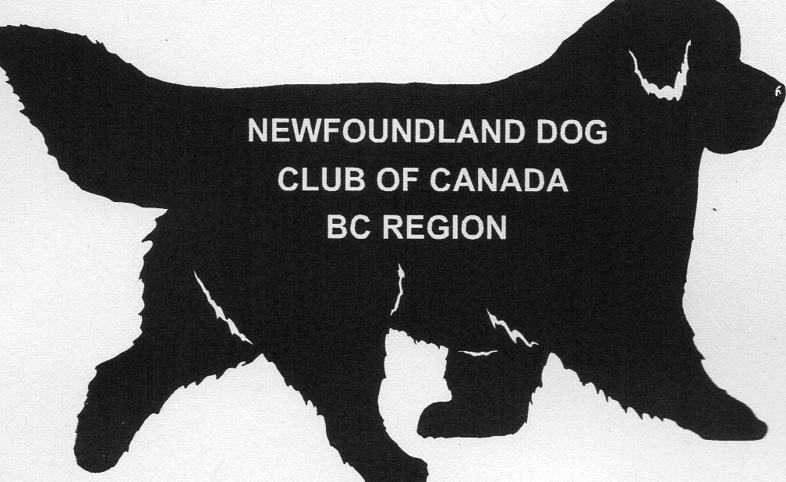
OFFICIAL CANADIAN KENNEL CLUB ENTRY FORM
Newfoundland Dog Club of Canada
ALL BREED Limited Entry Draft Test
Saturday, Sept. 24, 2016 – ENTRIES CLOSE: 6:00 PM PDT, Sept. 9, 2016
ENTRY FEE $__________ Listing Fee (if applicable): $8.93 TOTAL ENTRY FEE $__________
ENTRY FEE: $75 in Canadian or US Funds per entry. A Brace is one entry – please fill out two entry forms for a brace and attach together. Day of entries are allowed if places available.
LISTING FEE * $8.93 for entries that do not have a CKC number.
All fees payable, to: Newfoundland Dog Club of Canada – BC Region
Mail entry with payment to: Grace Edwards 5399 Sunnybrae Canoe Pt. Rd. Tappen, BC V0E 2X1
Reg’d Name of Dog: ____________________________________________________________________

Call Name: _________________________________ Breed: ____________________________________

Sex: □ Male □ Female (If Female, will she be in season on test day? □ Yes □ No
Test Class: □ DRAFT DOG □ DRAFT DOG EXCELLENT
□ BRACE DRAFT DOG □ BRACE DRAFT DOG EXCELLENT □ RE-QUALIFICATION
In case of brace teams, fill out separate entry form for each dog.
Note: If DDX entries do not fill they will be replaced with 2 DD entries.

Date of Birth: D_______M_______Y_______ Place of Birth: □ Canada □ Elsewhere
Check one and enter number: □ LISTED_____________________________
□ CKC Reg. #______________________ □ CKC ERN #______________________________
□ CKC Misc. Cert. # _________________________ □ CKC Pen #______________________
□ CCN Canine Companion #_________________________
Breeder(s): ___________________________________________________________________________

Sire: _________________________________________________________________________________

Dam: ________________________________________________________________________________

Reg’d Owner(s): ________________________________________________________________________

Owner’s Address: _______________________________________________________________________

City: ________________________ Prov.: ____________________Postal Code_____________________

E-Mail: ______________________________________________________________________________

Name of Owner’s Agent (if any) at Test:_____________________________________________________
I certify that I am the registered owner(s) of the dog or that I am the authorized agent of the owner(s) whose name(s) I have entered above and accept full responsibility for all statements made in this entry. In consideration of the acceptance of this entry, I (we) agree to be bound by the rules and regulations of the Canadian Kennel Club and by any additional rules and regulations appearing in the premium list.

Signatures(s):___________________________________ Phone: ________________________________

